
REPORT

ON

STUDENT RECORD MANAGEMENT SYSTEM (SRMS)

MD.NAMEER ( AP24110012022)

Project Based Learning of Course CSE 201 – CODING SKILLS - I


SRM UNIVERSITY AP
SUBMITTED TO
RAKESH RAMARAJU
CODING SKILLS - I



Acknowledgements

We express our sincere gratitude to SRM University AP and the faculty of the Department of Computer Science and Engineering for their guidance and support throughout the course of this project. We would also like to thank all my friends who provided valuable feedback and technical assistance during the development and testing phases. Their encouragement and collaboration made this work possible.



Abstract
This project presents a role based Student Management System developed in C using file handling and a menu-driven interface. The system supports three user roles: Admin, Staff, and Guest. Users authenticate using stored credentials, after which they are provided access based on their assigned role.
Admins can add, update, delete, search, and display student records. Staff can add, search, and display records, while guests are restricted to only searching and viewing data.
This project demonstrates secure file based login, role restricted access control, data persistence, and modular programming concepts.


Introduction

The purpose of this project is to simulate a role-based Student Record Management System using the C programming language.
The system securely stores credentials and student information using file handling.
The project demonstrates authentication, data storage, search operations, menu-driven programming, structured programming concepts, and user-based access control.


Objectives

- Manage student records
- Provide secure login for multiple user types
- Implement file handling for permanent storage
- Show role-based access (Admin, Staff, Guest)
- Use modular programming with functions


Main Text:

The Student Management System is a menu driven application developed using the C programming language. It uses file handling to store student records and login credentials permanently. The program begins with a login system where users must enter a valid username and password. Each user is assigned a role such as Admin, Staff, or Guest, and based on this role, the system provides different levels of access.
Admins have complete control and can add, update, delete, search, and display student records. Staff members have partial access and are allowed to add, search, and display records but cannot modify or delete them. Guests have the minimum privileges and can only view and search for student data.
Student details such as roll numbers, name, and marks are stored in a text file. Tasks like updating and deleting records are handled safely using a temporary file to ensure data integrity. The program follows a modular structure with separate functions for each operation, making it easy to understand and maintain.
Overall, the system demonstrates role based access, persistent data storage, and basic record management using C programming concepts and file handling.


Results

- The login system correctly authenticated users and displayed menu options based on their assigned role.
- Student records were successfully stored, retrieved, and displayed using file handling.
- All operations such as adding, searching, updating, and deleting student data worked correctly as per user permissions. - The program maintained data accuracy and consistency across multiple test runs, proving it to be reliable and functional.



Conclusion and Recommendations

The Student Management System successfully demonstrates rolebased access control, file handling, and structured programming in C. The system accurately manages student records and ensures data security by assigning different privileges to Admin, Staff, and Guest users. The modular approach makes the code easy to understand, maintain, and extend.


Student Management System Source Codes
7.1 Login System – User Authentication
Purpose:
This part of the program verifies the username and password from the credentials file and identifies the role (Admin, Staff, or Guest). It limits incorrect login attempts to enhance security.
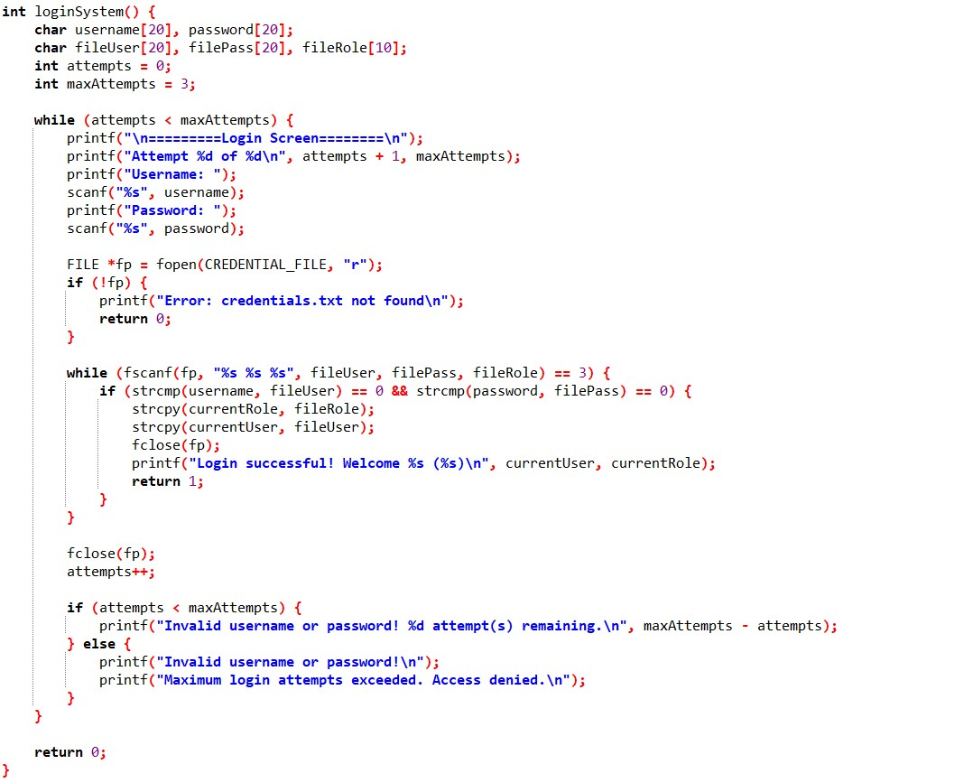

7.2 Role Based Menu System
Purpose:
Displays the appropriate menu depending on whether the logged-in user is an Admin, Staff, or Guest.
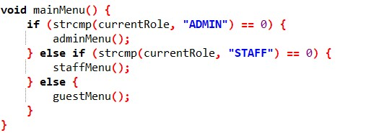
7.3 Add Student Function
Purpose:
Allows Admin and Staff to add a new student record to the file.
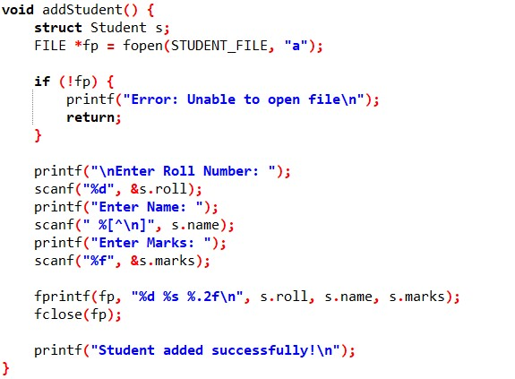

Search and View Records
Purpose:
Allows all roles to view stored student information and search by name.
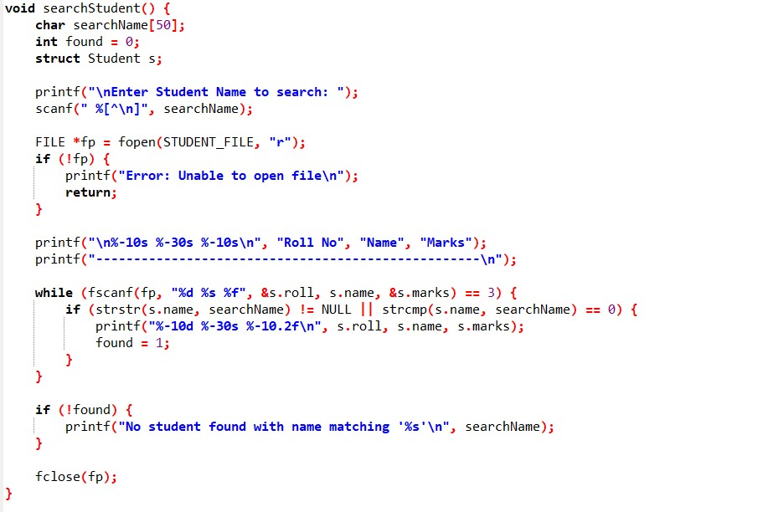

Update Records
Purpose:
Only Admins can modify existing student records while maintaining file integrity.
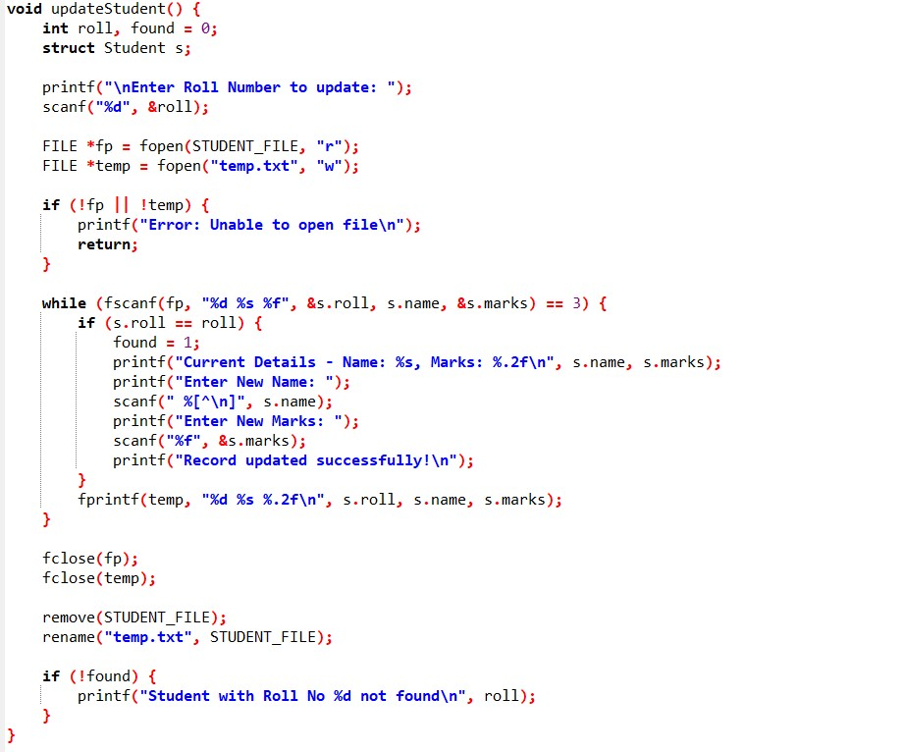

Delete Records
Purpose:
Removes a student record permanently by roll number and updates the stored data.
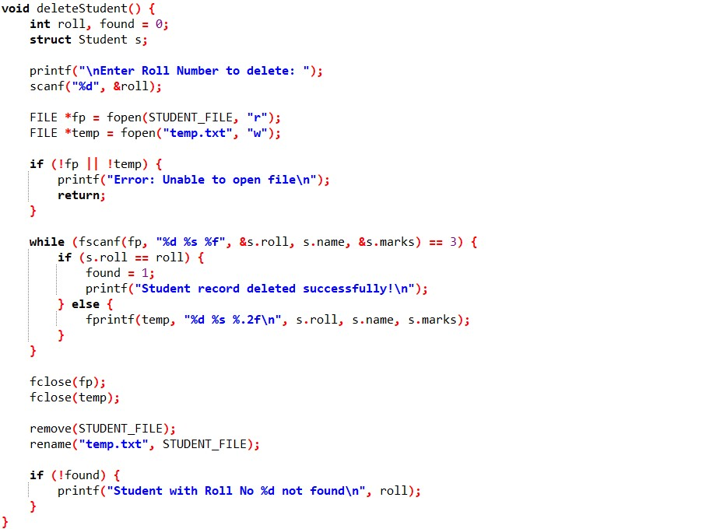

7.10 Main Function
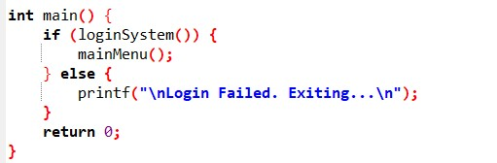
Sample Test Cases
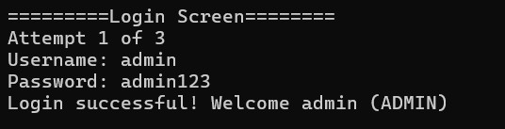
Login
:

Menu:
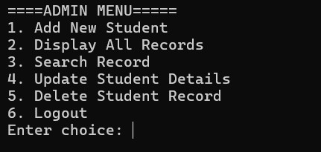
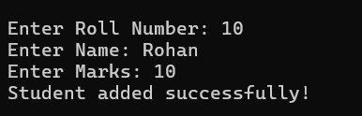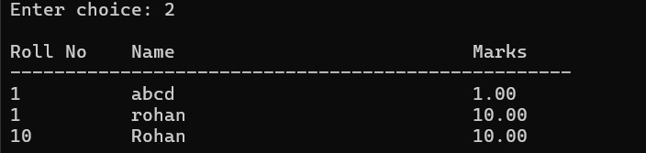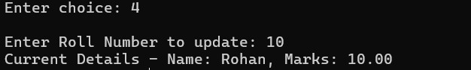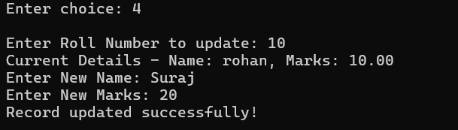
Add Marks
:

Display Records
:

Search Records
:

Update Records:

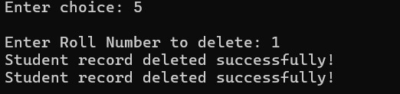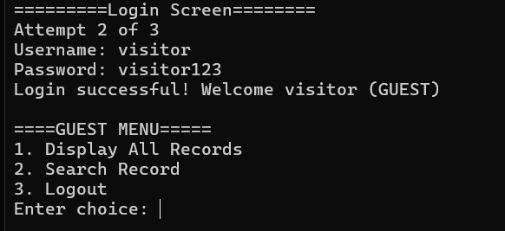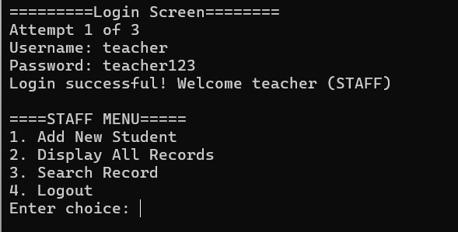
Delete Record
:

Guest Login
:

Staff Login:

